AI BASED SMART TASK SCHEDULING SYSTEM

ABSTRACT
The AI-Based Smart Task Scheduling System is a web/mobile application designed to help users manage their daily tasks efficiently using Artificial Intelligence. Many students, employees, and professionals struggle to organize tasks based on deadlines, priorities, and workload. This system uses AI algorithms to automatically schedule tasks in the most efficient way.
The application allows users to add tasks with deadlines, priority levels, duration, and category. The AI analyzes the tasks and generates an optimized schedule. It can also send reminders, suggest task rearrangements, and improve productivity.
The project demonstrates the use of AI concepts, task optimization, automation, and user-friendly scheduling systems.

1. INTRODUCTION
Time management is a major challenge for students and working professionals. People often forget deadlines, delay important work, or waste time on low-priority tasks.
Traditional to-do lists only store tasks but do not intelligently organize them. Therefore, an AI-based scheduling system is needed to automatically arrange tasks based on importance and available time.
This project provides a smart solution that improves productivity and reduces stress.

2. PROBLEM STATEMENT
Users face the following problems:
- Poor time management
- Missing deadlines
- Difficulty prioritizing tasks
- Manual scheduling takes time
- Low productivity
There is a need for a system that:
- Automatically schedules tasks
- Prioritizes important tasks
- Sends reminders
- Improves efficiency

3. OBJECTIVES
The main objectives are:
- To create an intelligent task scheduling system
- To prioritize tasks using AI
- To reduce manual planning effort
- To send reminders for deadlines
- To improve user productivity

4. SCOPE OF THE PROJECT
- Useful for students
- Useful for employees
- Can be used in organizations
- Can be integrated with calendars
- Can be extended with voice assistants

5. TECHNOLOGIES USED

Frontend:
- HTML
- CSS
- JavaScript
(or React.js)

Backend:
- Node.js / Python Flask / Django

Database:
- MySQL / MongoDB

AI/ML:
- Python
- Scikit-learn
- Task prioritization algorithm

APIs:
- Google Calendar API
- Notification API

6. SYSTEM ARCHITECTURE
Flow:
User → Task Input → AI Processing → Database → Optimized Schedule → Notification → User Dashboard

Steps:
- User enters tasks
- Task details are stored
- AI analyzes priority and deadlines
- System generates schedule
- Notifications/reminders are sent

7. PROJECT STRUCTURE
task-scheduler/
│── index.html
│── style.css
│── script.js
│── backend.py
│── database.db

8. WORKING PRINCIPLE
- User logs into the system
- Adds daily/weekly tasks
- AI checks:
  - Deadline
  - Priority
  - Duration
  - Free time slots
- System generates best schedule
- User receives reminders
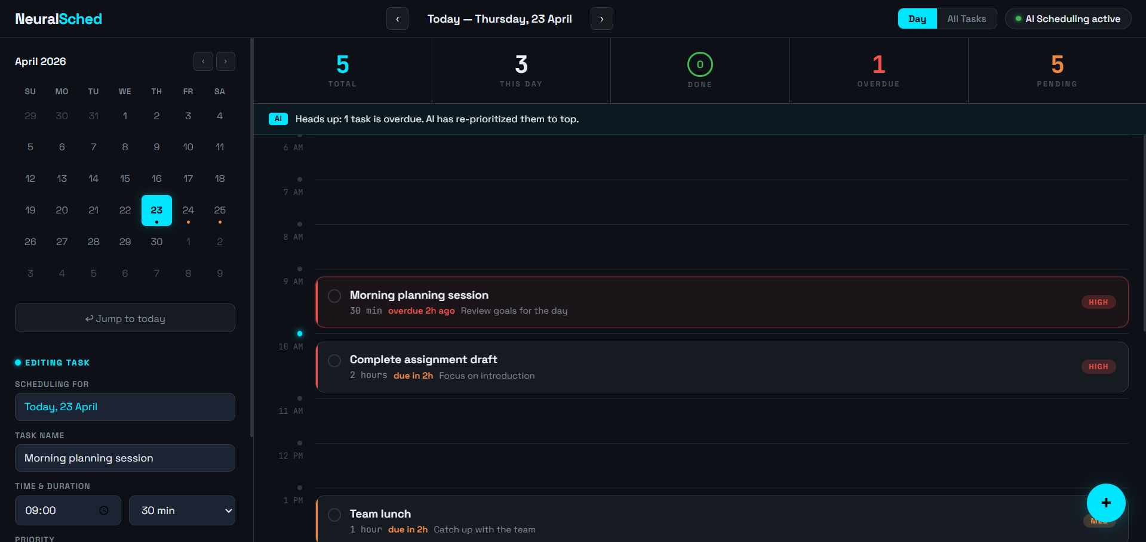
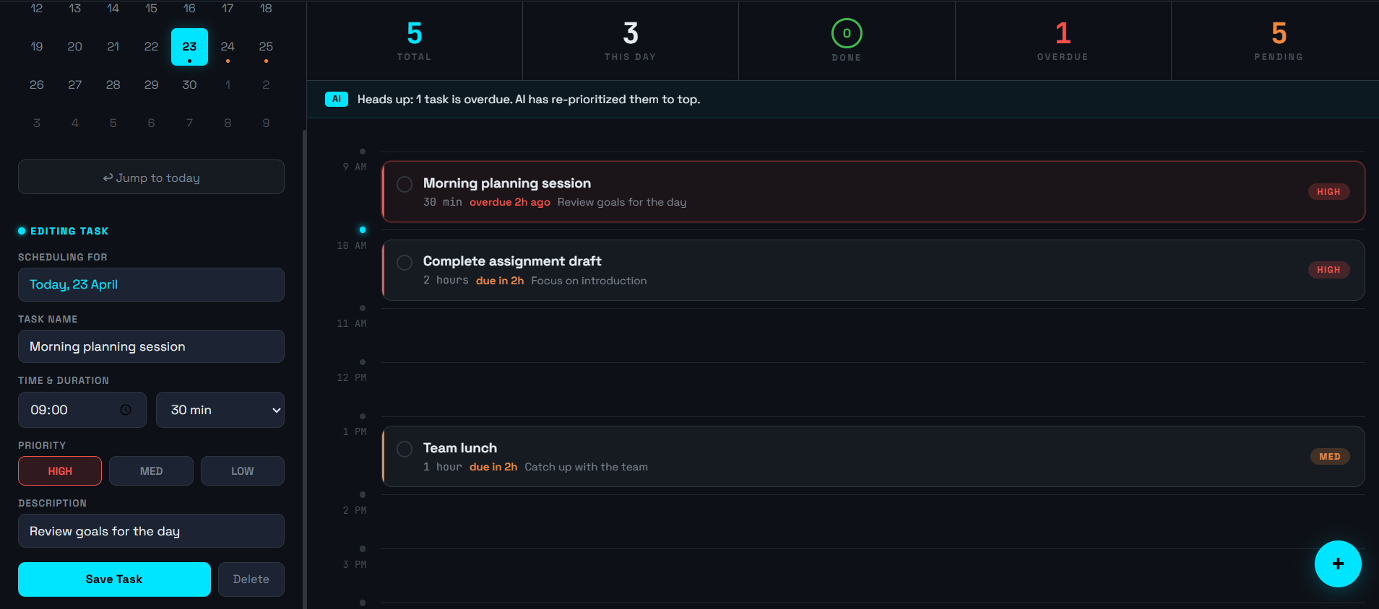
9. IMPLEMENTATION (MAIN CODE)
<!DOCTYPE html>
<html lang="en">
<head>
<meta charset="UTF-8">
<title>NeuralSched UI</title>
<style>
body {
margin: 0;
font-family: Arial, sans-serif;
background: #0b1220;
color: #fff;
}

/* Layout */
.container {
display: flex;
height: 100vh;
}

/* Sidebar */
.sidebar {
width: 280px;
background: #0f172a;
padding: 20px;
}

.logo {
font-size: 20px;
font-weight: bold;
color: #38bdf8;
margin-bottom: 20px;
}

.calendar {
margin-top: 20px;
}

.calendar table {
width: 100%;
text-align: center;
color: #94a3b8;
}

.calendar td {
padding: 8px;
}

.active-day {
background: #22d3ee;
color: black;
border-radius: 8px;
}

/* Main Content */
.main {
flex: 1;
padding: 20px;
}

/* Top Stats */
.stats {
display: flex;
gap: 20px;
margin-bottom: 20px;
}

.stat-box {
flex: 1;
background: #111827;
padding: 15px;
border-radius: 10px;
text-align: center;
}

.stat-box h2 {
margin: 0;
}

.stat-blue { color: #22d3ee; }
.stat-green { color: #22c55e; }
.stat-red { color: #ef4444; }
.stat-orange { color: #fb923c; }

/* Alert */
.alert {
background: #0f2a3a;
padding: 10px;
border-radius: 8px;
margin-bottom: 20px;
color: #38bdf8;
}

/* Tasks */
.task {
background: #111827;
padding: 15px;
border-radius: 12px;
margin-bottom: 15px;
border-left: 5px solid transparent;
}

.task.overdue {
border-left: 5px solid #ef4444;
}

.task.pending {
border-left: 5px solid #fb923c;
}

.task-title {
font-weight: bold;
}

.task-meta {
font-size: 14px;
color: #94a3b8;
}

/* Floating Button */
.add-btn {
position: fixed;
bottom: 30px;
right: 30px;
background: #22d3ee;
color: black;
width: 60px;
height: 60px;
border-radius: 50%;
font-size: 30px;
display: flex;
justify-content: center;
align-items: center;
cursor: pointer;
}
</style>
</head>

<body>

<div class="container">

<!-- Sidebar -->
<div class="sidebar">
<div class="logo">NeuralSched</div>

<div class="calendar">
<table>
<tr><td>Su</td><td>Mo</td><td>Tu</td><td>We</td><td>Th</td><td>Fr</td><td>Sa</td></tr>
<tr><td>19</td><td>20</td><td>21</td><td>22</td><td class="active-day">23</td><td>24</td><td>25</td></tr>
</table>
</div>
</div>

<!-- Main Content -->
<div class="main">

<!-- Stats -->
<div class="stats">
<div class="stat-box">
<h2 class="stat-blue">5</h2>
<p>Total</p>
</div>
<div class="stat-box">
<h2>3</h2>
<p>This Day</p>
</div>
<div class="stat-box">
<h2 class="stat-green">0</h2>
<p>Done</p>
</div>
<div class="stat-box">
<h2 class="stat-red">1</h2>
<p>Overdue</p>
</div>
<div class="stat-box">
<h2 class="stat-orange">5</h2>
<p>Pending</p>
</div>
</div>

<!-- Alert -->
<div class="alert">
⚡ Heads up: 1 task is overdue. AI has re-prioritized them to top.
</div>

<!-- Tasks -->
<div class="task overdue">
<div class="task-title">Morning planning session</div>
<div class="task-meta">30 min · overdue 2h ago · HIGH</div>
</div>

<div class="task pending">
<div class="task-title">Complete assignment draft</div>
<div class="task-meta">2 hours · due in 2h · HIGH</div>
</div>

</div>

</div>

<!-- Floating Button -->
<div class="add-btn">+</div>

</body>
</html>

10. TASK INPUT MODULE
Users can enter:
- Task name
- Deadline
- Priority
- Estimated duration
- Category
Example:
- Assignment submission
- Meeting
- Workout
- Exam preparation

11. AI PRIORITIZATION MODULE
The AI evaluates:
- Task urgency
- Task importance
- Available time
- User behavior patterns
It assigns priority scores and schedules tasks accordingly.

12. REMINDER SYSTEM
The system sends reminders through:
- Email notifications
- Mobile notifications
- SMS alerts
Example:
"Your project deadline is tomorrow."

13. DASHBOARD DISPLAY
The dashboard shows:
- Today’s tasks
- Completed tasks
- Pending tasks
- Upcoming deadlines

14. CALENDAR INTEGRATION
The system integrates with Google Calendar to:
- Add scheduled tasks
- Sync deadlines
- Set reminders

15. AI IMPROVEMENT FEATURE
The system learns user habits such as:
- Peak productivity hours
- Frequently delayed tasks
- Preferred work timings
It improves scheduling over time.

16. FEATURES
- Smart scheduling
- AI task prioritization
- Notifications
- Calendar integration
- Productivity tracking
- User-friendly interface

17. ADVANTAGES
- Saves time
- Improves productivity
- Reduces stress
- Prevents missed deadlines
- Automates scheduling

18. LIMITATIONS
- Requires internet for cloud features
- AI predictions may not always be perfect
- Depends on user input accuracy

19. FUTURE ENHANCEMENTS
- Voice assistant integration using Google Assistant or Siri
- Advanced machine learning models
- Team collaboration features
- Mobile app development
- Integration with Microsoft Outlook

20. CONCLUSION
The AI-Based Smart Task Scheduling System is an efficient solution for managing daily activities intelligently. It helps users organize tasks, meet deadlines, and improve productivity through automation and AI techniques. It has strong future potential in education, workplaces, and personal productivity management.

TEAM MEMBERS:
2320030014-Jaswitha Reddy
2320030114-Praneetha
2320030128-Sri Vennela

